Lesson 10 Preview

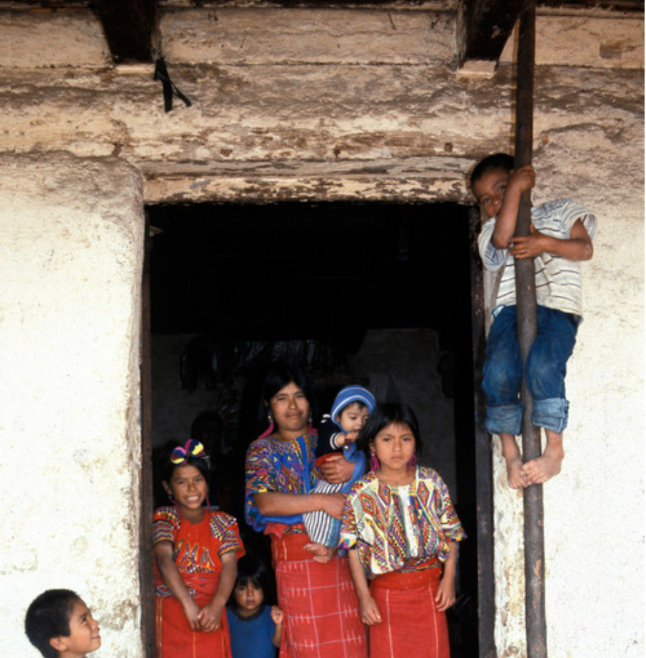

1. Find four interesting or important details in the photograph and describe them.

| They are indians | They’re culture is Maya Indians | They don’t have shoes and they are really dirty. | They look like they live in a bad place |
| --- | --- | --- | --- |

1. This family is preserving its traditional culture. What do you see in the photograph that shows this? The girls both have the same dresses and they also are living in the place where they’re ancestors used to live.
2. This family has also adapted to modern life. What do you see in the photograph that shows this? They have technology.
3. Do you think this family is more traditional or more modern? Support your answer with at least three details from the photograph. I think the family is more traditional because they have the same clothes except for the boys, they live in their ancestors building, and they only have one piece of technology with them.